Social Activism 2.0 – Hashtag Activism
Katherine A. Rosenblad-Pietzold
University of Southern California

Introduction:
Hashtag activism, introduced in 2007, is a relatively newer but common phenomenon in the digital media ecosystem that has added value and strength to the roles of social activism. Since its inception, it has been used in the communal spaces of social media to build community, demonstrate invention, and demand action. The continually growing popularity and use of social media, along with its influence on numerous aspects of life, is illustrated through the successful practice of hashtag activism as seen with #Kony2012 campaign across multiple platforms and #BlackLivesMatter on Twitter (Van, 2014).

Background History:
Defining a Hashtag
A hashtag is more than just a “#” followed by a word or phrase. It has functionality that allows for “sorting and selecting thematically related information from a torrent of messages” within the context of social media platforms. In the context of Twitter, a hashtag is defined as: Any word(s) preceded by a hash sign “#” to note a subject, event, or association – it is a symbol. Hashtags are an integral part of the social media platforms’ ability to link the conversations of strangers together and is important factor in the success of hashtag activism (Van, 2014).

Invention of the Hashtag
Initially, the hashtag was used within Internet chat rooms. Then, on August 23, 2007 – Chris Messina suggested that the symbol should be used in other platforms, specifically Twitter. He conceptualized and presented what this kind of feature could look like on Twitter and initially called them “channels,” but was suggested by another individual to call them “hash tags.” At first the executives at Twitter didn’t think this idea would take off. However, during the San Diego, California forest fires in October 2007, the use of the hashtag became popular (Van, 2014). At the suggestion of Messina to a friend, his friend added #sandiegofire to his tweets and other users quickly picked it up (Mbabazi and Mbabazi, 2018).
The year prior, in 2006, Twitter made its debut in social media as a “micro-blogging site” through which in 140 characters, users have the opportunity to send short “tweets” out into the world. “In the use of Twitter, an important communication medium had been discovered, which, especially as far as the distribution of news is concerned, changed the world on a variety of levels” (Van, 2014). Therefore, when people began using #sandiegofire as a way of disseminating updates and news on the situation, they too were actively changing the world and demonstrating the power of social media. The implementation of the hashtag elevated the abilities of Web 2.0, or social media networking, because it is used to “refer to a variety of matters, ranging from news events to jokes. The use of the hashtag was officially put into effect in July 2009 by the Twitter platform, to be followed in 2011 by Google+ and Instagram, whilst Facebook began to make use of this idea in June 2013 (Socialmedia Today 2014)” (Van, 2014).
Therefore, by “adding the hashtag sign # to a word, such as #change or #climate, it makes it easier for other users on Twitter to search, link, and interact with one another via the hashtagged word and to share stories related to it” (Yang, 2016). Generally, hashtags are more of a neutral phrase or word that hinders on its use to bring awareness and critique. “Some postings have hundreds of ‘favorites’ and ‘retweets.’ Individuals in these communal spaces may or may not know one another.” Posts can contain images, jokes, slogans, and critiques. They can link to news, videos, music, and songs. Or, the hashtagged phrase can stand alone (Yang, 2016).
For instance, anyone using the hashtag #BlackLivesMatter is still sharing in the same moral, political, and social implications of its use. The participation in hashtag activism does not require participants to know one another, but rather to share in the same ideas and work towards a common goal. Similar to that of how a photo is worth a thousand words, the hashtag alone is a story in and of itself. It defines all that needs to be said.
With access to this technology, the volume of participating voices is continuously fluctuating up and down because of how unique of a feature the hashtag is. The easier it is for individuals to use and interact with this form of activism, the more people will choose to participate. Thus, activism with a hashtag becomes a powerful and connective concept for audiences.
This hashtag activism presents a “recognizable narrative form with a beginning, a crisis/conflict, and an end” that individuals are able to build a collective story and present a united strength through their personal thoughts, emotions, and stories (Yang, 2016). These hashtags, however, are at their most successful when they are short and easy to understand. They can only attract a wider audience if people can easily grasp them (Mbabazi et al., 2018).

From “Hashtag” to “Activism”
An incidence of hashtag activism takes place when large numbers of comments and retweets appear on social media in response to a hashtagged word, phrase, or sentence with a social or political claim. The hashtags used for this form of activism have a distinctly narrative character that is in “contrast to ‘traditional’ forms of digital activism such as distributed denial-of-service actions (DDoS) or signing online petitions.” Because these posted comments and retweets consist of numerous personal stories and appear in temporal order, they assume a narrative form (Yang, 2016). A narrative form that is central to hashtag activism because of its clear storytelling and meaning-making abilities (Van, 2014). Additionally, this form of digital activism is used as a “discursive protest on social media united through a hashtagged word, phrase or sentence” (Yang, 2016).
Some of the more popular hashtag examples used in hashtag activism include: #Kony2012, #StopKony, #BlackLivesMatter, #Ferguson, #TakeAKnee, #ICantBreathe, #MeToo, #BringBackOurGirls, #OscarsSoWhite (Yang, 2016). #Kony2012 and #StopKony are hashtags used in a 2012 social media campaign for Invisible Children. The organization’s main goal was to raise awareness about the social crisis of Josephy Kony, “a warlord who had led the Lord's Resistance Army, an extremely violent militant movement known for its use of child soldiers in Uganda and central African states.” Their main message: “stop Kony” (Taylor, 2014). In the two years following the #Kony2012 campaign, #BlackLivesMatter and #Ferguson were both created as responses to protest movements that happened in the streets and on social media. #BlackLivesMatter was created in July 2013 by Alicia Garza in response to the acquittal of George Zimmerman in the shooting death of an African-American teenager Trayvon Martin. Almost a year later, another hashtag (#Ferguson) was created in response to yet another shooting death of an African-American Michael Brown. “These important cases of online protests brought renewed attention to the power of digital activism in shaping public discourse” through their complete sentence structures rather than single words like #change (Van, 2014; Yang, 2016).

Current Challenges and Opportunities:
Is Hashtag Activism an Effective Form of Advocacy?
In the case of #Kony2012/#StopKony, it went from 66,000 viewers it first day to 9 million the second. The hashtag was attached to a YouTube video about the rising issue and Oprah Winfrey reposted it to her nearly 10 million followers. Other celebrities followed suit and continued to bring awareness to this campaign. Within six days of the campaign’s debut, it reached more than one-hundred million views (20 million of those views were from social media platforms alone) (Invisible Children, 2014). Large groups of people came out in droves to support the cause, millions of campaign funds were raised to expand its efforts in Central Africa, and its creators’ original purpose of bringing awareness to an issue very few knew of or were concerned with was met (Taylor, 2014). The widespread use of the hashtag demonstrates the overall success hashtag activism can have when it stays on point and clearly states its purpose.
Additionally, in the case of #Kony2012, because of its widespread awareness in such a short amount of time it became a largely trendy thing to post about. As of 2019, #StopKony and #Kony2012 are used very little and Kony was never caught. Despite being considered so incredibly successful by its creators with Invisible Children, it could be considered one of the greatest examples of “slacktivism” (Taylor, 2014). #Kony2012 stood strong for two years, whereas the hashtag to follow it continues to stand strong since its first implementation, nearly six years ago.
From the first use of #BlackLivesMatter in July 2013 to May 2018, its use and popularity has increased and is often seen in conversations centering on issues related to race, violence, and law enforcement, and its usage periodically surges surrounding real-world events – most prominently, during the police-related deaths of Alton Sterling and Philando Castile and the subsequent shooting of police officers in Dallas, Texas and Baton Rouge, Louisiana, in July 2016 (Anderson, Toor, Rainie, and Smith, 2018). #BlackLivesMatter is an “archetypal example of modern protests and political engagement on social media: A new Pew Research Center analysis of public tweets finds the hashtag has been used nearly 30 million times on Twitter – an average of 17,002 times per day” (Anderson et al., 2018).
Demonstrated in the chart below, #BlackLivesMatter has continuously trended since its implementation, and as moments of political and social unrest occur, such as officer involved shootings, it trends upwards even more. Specifically, during a 10-day period in the summer of 2016, #BlackLivesMatter saw a significant increase in its use. It’s average daily use increased from 17,002 times per day to 500,000 times per day – that’s a nearly 2,940% increase in use (Anderson et al., 2018).
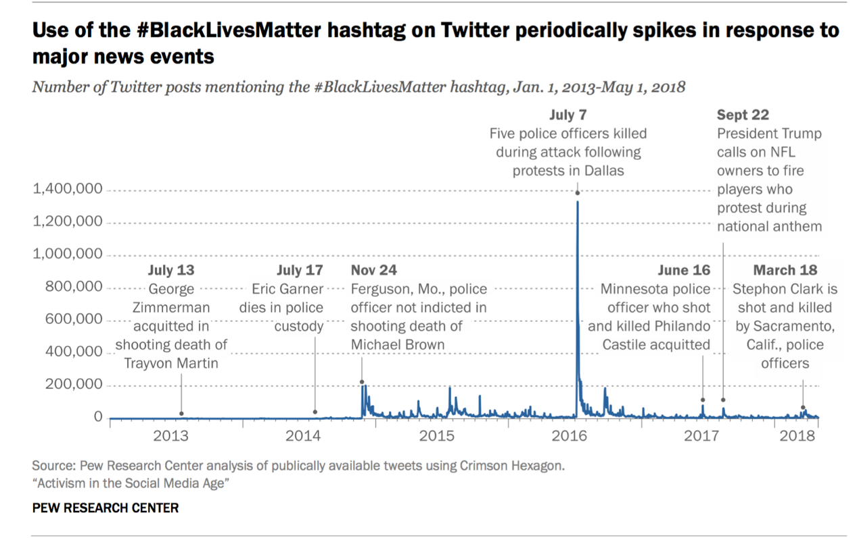

During the summer that many of these incidents occurred, I would have to include myself in these statistics. I found myself very active in using #BlackLivesMatter and other hashtags related to the situations. While, I didn’t go out in protests, I felt very compelled to use these hashtags and encourage others to engage in the posts across all of my social media platforms. I retweeted, posted original content, and participated in conversations going back-and-forth on Twitter, Facebook, and Instagram. I truly felt like I was an active participant in the matter, regardless that I was not actually buying protest themed apparel, sending money to the rising foundations, or actively standing in the street with a sign protesting. In my online participation via hashtag activism I still felt as though my voice was a part of the conversation and working towards the common goal of seeking justice and answers. My online participation fed into my offline life as well. I shared what I was reading and thinking with those around me, and we discussed what could be done; then, they too took to hashtag activism within the digital media ecosystem.
Some might argue that I was a “slacktivist” because I did nothing more than have conversations and share information via the digital media ecosystem. However, from the data to follow (see page nine), I would say that the whole point of hashtag activism is not only to demand change through a call to action but to raise awareness of a rising political situation, which is exactly what I did. To be a “slacktivist,” I believe my motive would have to have been different. I would have had to have only been participating to say that I had and to be trendy. But, even then, I believe sharing this information is better than not sharing it at all. Audiences alike are collectively engaging with and giving voice to the issues. The story behind the causes and issues gain power, and those with power are able to influence real change.

Social Activists (and Slacktivists) Drive Hashtag Use
According to a 2018 study, Activism in the Social Media Age, conducted by the Pew Research Center, around half of Americans surveyed reported having engaged in some form of political or social-minded activity on social media in the past year. Of those, 32% said they “encouraged others to take action on issues important to them” and 14% said they “used hashtags related to a political/social issue” (Anderson et al., 2018). By its design, hashtag activism demands a change and provokes a call to action by all its participants, big or small. Therefore, the above participants are influenced by and influencing those around them in the digital and real world (pictured bottom left).
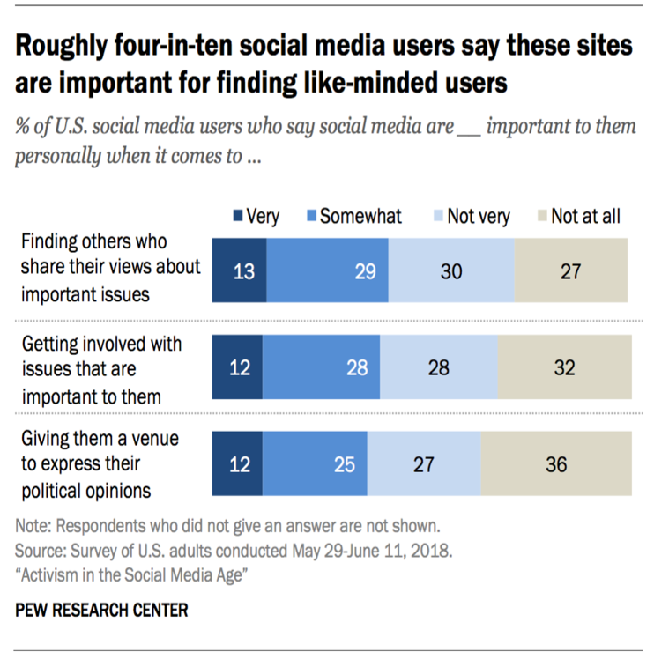
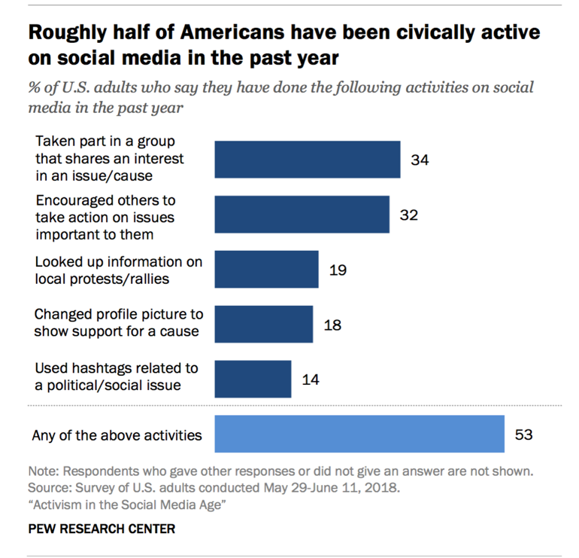

This engagement and influence is backed up when combined with the ideas that “roughly four-in-ten social media users say these sites are important for finding like-minded users” and that “the public as a whole, [not just social media users], has positive impressions of the ability of social media to help enact sustainable political change” (pictured top right). Additionally, 67% of those surveyed also believe that social media is at least “somewhat important for creating sustained movements for social change” and “58% agree that social media is at least somewhat important for influencing policy decisions” (Anderson et al., 2018). Overall, these facts demonstrate the limited, yet effective role of hashtag activism in social media. They also demonstrate that over half of Americans feel positively towards social media (thus, hashtag activism) to make a difference in helping gain attention and seek solutions for an issue.
On the same note, those that do not agree with these statements on hashtag activism may argue that its use is not effective because of so-called “slacktivists.” “Slacktivists” tend to engage with the tweets to be trendy or for the sake of doing it, instead of truly caring about the issue. All of these attentions bring people to question if hashtag activism is actually making a positive and effective difference or if it is simply a way for people to make themselves feel better about a situation because they retweeted or posted something with the popular hashtag. Many have put faith into the idea that hashtag activism in the digital media ecosystem can be effective in gaining attention by the right audiences; and, some “64% of Americans feel that the statement ‘social media help give a voice to underrepresented groups’ describes these sites very or somewhat well, according to the same research survey (Anderson et al., 2018).
However, there is a larger share that questions what that “voice” is. Participants (77%) said they believed “social networking sites distract people from issues that are truly important, and 71% said they agree with the assertion that ‘social media makes people believe they’re making a difference when they really aren’t’.” This passive participation can help a hashtag trend online, but it creates the idea that the situation is being dealt with, when in reality it really may not be (Anderson et al., 2018). This study suggests that failed hashtags are ones that only offer critique and the successful ones are those that have a call to action. Participants of hashtag activism are able to make an impact or influence an action (sometimes with little contribution) and some participate merely just to say they did.

“Freedoms” of Hashtag Activism
Nevertheless, while hashtag activism can and is effective in many ways, these challenges demonstrate hashtags cannot be solely relied on to resolve an issue (Mbabazi et al., 2018). When they are not approached in the right manner, hashtags used in hashtag activism can be considered negative. The risk in creating a negative hashtag is that it can create the wrong following and have a negative impact on someone’s image or organization (both the creator and the target), which might also demolish the purpose of which they are formed. Hashtag activism can be extremely effective when its creator and users have a clear goal; however, many hashtag campaigns fail because of their intention to destabilize societies, controversy, and lack of a clear message (Mbabazi et al., 2018). The ease and affordability at which hashtag activism can be pursued and participated in lends itself to a wide audience, making it a convenient means of communication for anyone to use.
Hashtag activism is a more affordable way to participate because every post is free to make and requires a different form of risk. Thanks to the advent of social media in the digital media ecosystem, hashtag activists can participate from the comfort of their home, job, and/or a rally. Not every person in the 30 million tweets curated in the first five years (2013 to 2018) of #BlackLivesMatter is out walking the streets or in courthouses protesting in the physical world, they are still actively participating in the digital realm (Anderson et al., 2018). It could be argued that this presents as a challenge to hashtag activism because there is more action online than offline, but it’s the tweets’ content and the conversations that are being had through them that are so important.
The other caveat to the freedom of hashtag activism is that it is so public. An employer or friend could take notice of a participant’s digital footprint and choose to react in a negative matter. Activism no longer requires one to maintain a single identity. The digital media ecosystem allows participants to choose the spaces within which they are an activist, whether that be one, both, or none.
Furthermore, this freedom is further expressed because hashtag activism is so “pocket friendly.” It is extremely mobile via smartphones, laptops, and tablets. Nearly everyone has access and is able to view or publish information using these tools because of the increased access to the Internet. Our society has become reliant on digital technology and the quickness it can provide, which is beneficial in the case of hashtag activism and Twitter (Van, 2014).
However, if one lacks access to the internet it inhibits their ability to partake in hashtag activism. Therefore, it could be argued hashtag activism is not as inclusive as one might believe it to be. This can be overcome, though, through the hashtags use outside of the digital media ecosystem. People share ideas online as well as offline. A participant of digital hashtag activism can share their experiences with someone offline in which the hashtag evolves back to traditional protest with banners, t-shirts, and word-of-mouth. It still maintains widespread use and fluidity.

Influence/Impact of Topic On Society:
Hashtag Activism Drives Modern Protests
The advantage of hashtag activism in the digital media ecosystem is that it keeps the conversation going. Hashtag activism has evolved as Twitter has evolved from the original prompt What are you doing? to What’s happening? It creates a space in which metadata can easily be searched and filtered on platforms so that people can track and be introduced to rising situations. News is “being conveyed much faster by means of so-called public journalism” (Van, 2014).
Within moments of an issue occurring, the digital media ecosystem allows for anyone to report on it. The way in which hashtags are actively used to give phrases or even individual words meaning and power demonstrates how activism has evolved in the digital media ecosystem. “They encourage audience participation. People participate by reading, retweeting, commenting on others’ tweets or posting their own with the same hashtag.” Every hashtag tells a story, often times personal. All of these stories are linked to broader social issues and shared with the public through the simplistic, communal, and collective nature of a hashtag. It is in how these hashtags are used in which they can become a unifying theme of multiple stories and aid in the new digital era of activism, hashtag activism (Yang, 2016).
Successful or popular hashtags tend to “contain verbs expressing a strong sense of action and force. The actions are petitioning, demanding, appealing, and protesting. They express refusals, objections, and imperatives to take immediate action” (Yang, 2016). The way in which hashtags are actively used to give phrases or even individual words meaning and power demonstrates how activism has evolved in the digital media ecosystem. “They encourage audience participation. People participate by reading, retweeting, commenting on others’ tweets or posting their own with the same hashtag.” Every hashtag tells a story, often times personal. All of these stories are linked to broader social issues and shared with the public through the simplistic, communal, and collective nature of a hashtag. It is in how these hashtags are used in which they can become a unifying theme of multiple stories and aid in the new digital era of activism, hashtag activism (Yang, 2016).
As seen in earlier examples, Chris Messina implemented the first use of hashtagged phrases with #sandiegofire, then #Kony2012 (or #StopKony) by Invisible Children, and a few years later Alicia Garza created #BlackLivesMatter. These hashtags, like many others, are successful because of the impact and awareness they bring. They follow a basic set of principles by containing “verbs expressing a strong sense of action and force. The actions are petitioning, demanding, appealing, and protesting. They express refusals, objections, and imperatives to take immediate action” (Yang, 2016).
Past activism is more commonly thought of as large protests – once witnessed as a physical force through marches and riots in the streets, demonstrations in public spaces and boycotts of transportation and products – Now, with the implementation of hashtags, protests have moved to the digital world too. With the evolution of protests, there is little space for one to ignore a rising situation. Trending topics make their way through the filters of social media and rise to the top of each feed and into the posts of those individuals choose to follow or engage with. It is easy to turn-a-blind-eye when walking by a group of individuals with signs in the street, but it is hard to do the same online. Hashtag activism enables wide outreach amongst audiences on issues that ordinary activism may restrict to an individual situation (Mbabazi et al., 2018).

Resurgence of the Athlete Activist
While it may be easy to walk past a group protesting with signs, it is hard to ignore your favorite athlete or sports team when they are protesting. Personally, I believe there has been a large resurgence in “athlete activism” within the past six years, since #BlackLivesMatter was birthed. The National Football League (NFL) and National Basketball Association (NBA) have been in the news numerous times due to athletes’ and teams’ decisions to protest. NBA player LeBron James and NFL player Colin Kaepernick have been some of the more outspoken professional athletes using the hashtags #BlackLiveMatter, #ICantBreathe, #Ferguson, etc. both online and offline. Their efforts have been followed by many other professional athletes, but these two stand out because they continue to actively engage their communities, their fans, and online followers in protest.
LeBron James and other NBA players wore t-shirts with “#ICantBreathe” written across them during warmups throughout the season and wrote several hashtags across their shoes or athletic tape. Many NFL players did the same. Additionally, following a 10-day period in which #BlackLivesMatter saw a 2,940% increase in its use due to the numerous officer-involved shootings of black men, James alongside Carmelo Anthony, Dwayne Wayde, and Chris Paul (other prominent NBA players) used their position to give a speech at the 2016 ESPY Awards (Excellence in Sports Performance Yearly) (Anderson et al., 2018). In their speech they asked other athletes to continue the athlete activist legacy and use their voices to demand a better reality for current and future generations:
Anthony: Good evening. Tonight is a celebration of sports, celebrating our accomplishments and our victories. But, in this moment of celebration, we asked to start the show tonight this way — the four of us talking to our fellow athletes with the country watching. Because we cannot ignore the realities of the current state of America. The events of the past week have put a spotlight on the injustice, distrust and anger that plague so many of us.
The system is broken. The problems are not new. The violence is not new. And the racial divide definitely is not new. But the urgency to create change is at an all-time high.
Paul: We stand here tonight, accepting our role in uniting communities, to be the change we need to see. We stand before you as fathers, sons, husbands, brothers, uncles — and in my case, as an African-American man and the nephew of a police officer, who is one of the hundreds of thousands of great officers serving this country.
But, Trayvon Martin. Michael Brown. Tamir Rice. Eric Garner. Laquan McDonald. Alton Sterling. Philando Castile. This is also our reality.
Generations ago, legends like Jesse Owens, Jackie Robinson, Muhammad Ali, John Carlos and Tommie Smith, Kareem Abdul-Jabbar, Jim Brown, Billie Jean King, Arthur Ashe and countless others, they set a model for what athletes should stand for. So we choose to follow in their footsteps.
Wade: The racial profiling has to stop. The shoot-to-kill mentality has to stop. Not seeing the value of black and brown bodies has to stop. But also, the retaliation has to stop. The endless gun violence in places like Chicago, Dallas, not to mention Orlando, it has to stop. Enough. Enough is enough.
Now, as athletes, it’s on us to challenge each other to do even more than we already do in our own communities. And the conversation, it cannot stop as our schedules get busy again. It won’t always be convenient. It won’t. It won’t always be comfortable, but it is necessary.
James: We all feel helpless and frustrated by the violence. We do. But that’s not acceptable. It’s time to look in the mirror and ask ourselves what are we doing to create change. It’s not about being a role model. It’s not about our responsibility to the tradition of activism.
I know tonight we’re honoring Muhammad Ali. The GOAT. But to do his legacy any justice, let’s use this moment as a call to action for all professional athletes to educate ourselves. It’s for these issues. Speak up. Use our influence. And renounce all violence.
And most importantly, go back to our communities, invest our time, our resources, help rebuild them, help strengthen them, help change them.
We all have to do better. Thank you. (Chan, 2016).
This speech, in its entirety, is important because it demonstrates the call to action athletes are demanding of themselves as they recognize the importance of their role in society. It also demonstrates their recognition of the need for a call to action by everyone. The unfortunate incidents that inspired and influenced the creation of hashtags such as #BlackLivesMatter have created an ability for people to demand and create change.
In the following month after this speech, NFL quarterback Colin Kaepernick (and his teammate Eric Reid) led a silent protest by taking a knee during pregame performances of the National Anthem. Many other prominent professional football players, even whole teams, followed suit, sparking an uproar amongst not only football fans but amongst the entire United States of America. Much like Tommie Smith and John Carlos in the 1968 Summer Olympics, this demonstration raised the eyebrows of many and sparked an ongoing conversation. Kaepernick, like Smith and Carlos, has been blackballed by his sport but hailed as a hero by those he’s fighting for and with (Reid, 2017).

Conclusion:
Moved by the uproar of hashtag activism and real-life events, hashtags such as #TakeAKnee bore out of Kaepernick’s protest and have flourished alongside the 30 million-plus uses of #BlackLivesMatter. Not everyone takes action beyond the use of a hashtag, but when they do it can be fairly significant, especially when powerful voices such as James or Kaepernick step forward. Therefore, the overall outlook remains positive in the effectiveness of hashtag activism.
A majority of “Americans do believe these [social media] sites are very or somewhat important for accomplishing a range of political goals, such as getting politicians to pay attention to issues (69% of Americans feel these platforms are important for this purpose) or creating sustained movements for social change (67%)” (Anderson et al., 2018). #Kony2012 and #BlackLivesMatter have and continue to demonstrate that the internet and its digital media ecosystem work as a communications infrastructure for participation, interactivity, collaborative learning, and social networking (Van, 2014). Therefore, engagement and participation in posts (by all users) involving hashtag activism helps achieve the overall goal of these hashtags, which is to bring awareness and bring justice to a rising situation.

References

Anderson, M., Toor, S., Rainie, L., & Smith, A. (2018). Activism in the social media age. ().Pew
Research Center. Retrieved from Social Science Premium Collection Retrieved from
http://libproxy.usc.edu/login?url=https://search-proquest-
com.libproxy2.usc.edu/docview/2084779902?accountid=14749
Chan, M. (2016, July 14). LeBron James Speech at ESPY Awards: Read the Transcript.
Retrieved from https://time.com/4406289/lebron-james-carmelo-anthony-espy-awards-transcript/.
Invisible Children (Ed.). (2014, October 14). One year later // KONY 2012 & infographics.
Retrieved from https://invisiblechildren.com/blog/2013/03/03/one-year-later-kony-2012-infographics/.
Mbabazi D., & Mbabazi J. (2018, September 27). Hashtag Activism: Powerful or Pointless? The
New Times. Retrieved from https://www.newtimes.co.rw/society/hashtag-activism-powerful-or-pointless
Reid, E. (2017, September 25). Eric Reid: Why Colin Kaepernick and I Decided to Take a Knee.
Retrieved from https://www.nytimes.com/2017/09/25/opinion/colin-kaepernick-football-
protests.html.
Taylor, A. (2014, Decemeber 16). Was #Kony2012 a failure? Retrieved from
https:www.washingtonpost.com/news/worldviews/wp/2014/12/16/was-kony2012-a-
failure/.
Van, d. B. (2014). The story of the hashtag(#): A practical theological tracing of the hashtag(#)
symbol on twitter. Hervormde Teologiese Studies, 70(1), 1-6. Retrieved from
http://libproxy.usc.edu/login?url=https://search-proquest-
com.libproxy2.usc.edu/docview/1680763304?accountid=14749
Yang, G. (2016). Narrative agency in hashtag activism: The case of #BlackLivesMatter. Media
and Communication, 4(4) doi:http://dx.doi.org.libproxy2.usc.edu/10.17645/mac.v4i4.692

